1) Install Git
Windows
- Install Git Bash from: https://git-scm.com
Verify

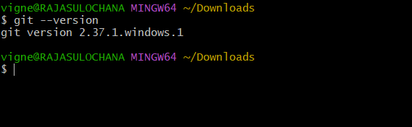

2 Create a GitHub Repository (with README & .gitignore)
- Go to GitHub → New Repository
- Repo name: git-practice
- Check Add README.md
- Add .gitignore (choose language if needed)
- Click Create repository

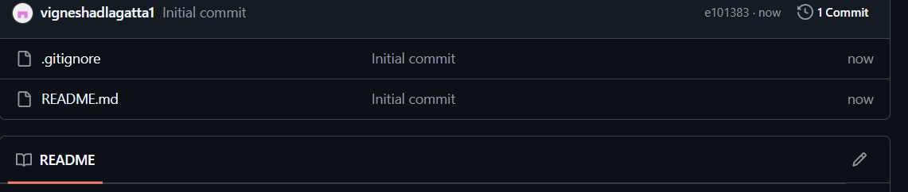

3 ) Clone the Repository to Local

git clone https://github.com/<your-username>/git-practice.git
cd git-practice
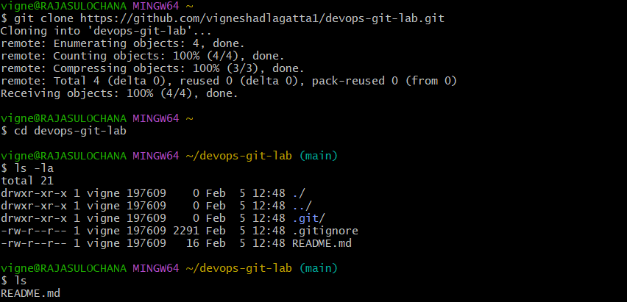



4) Create Two Files in Local Repo

touch file1.txt file2.txt
echo "This is file1" > file1.txt
echo "This is file2" > file2.txt

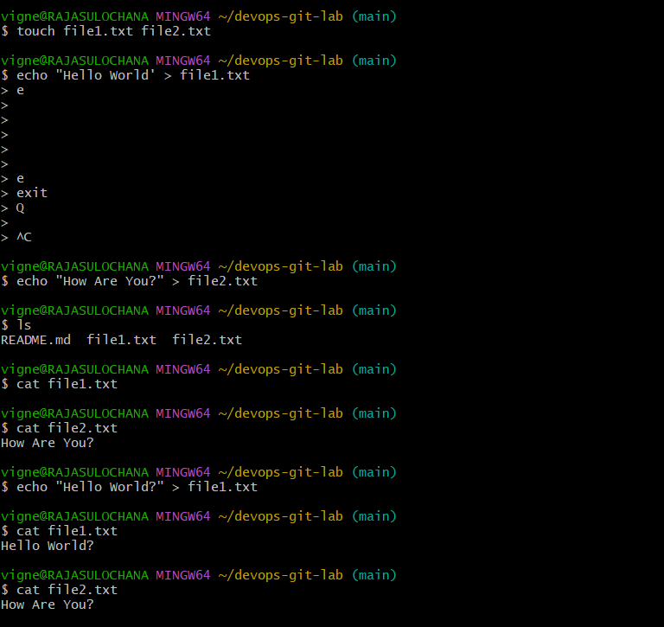

5) Commit Two Files and Push to Central Repository

git add file1.txt file2.txt
git commit -m "Added two files"
git push origin main
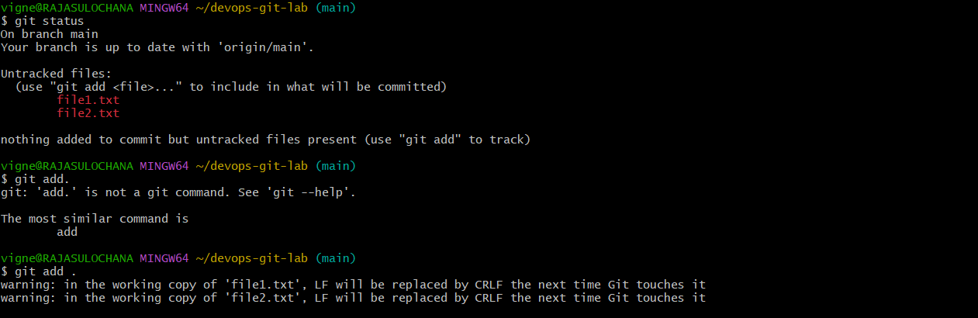

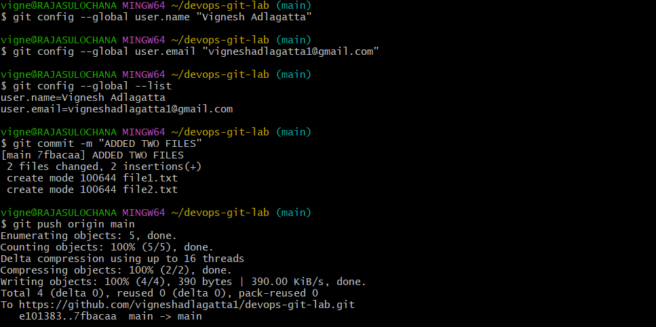

6) Create a Branch in Local, Add File, Push to Central
git checkout -b dev-branch
touch sample.txt
git add sample.txt
git commit -m "Sample file in dev branch"
git push origin dev-branch

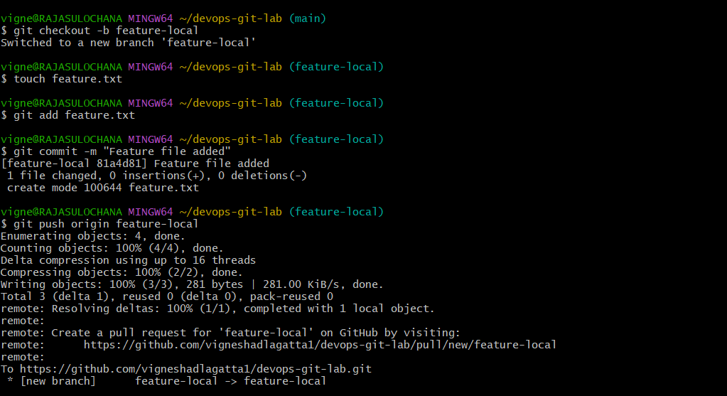

7) Create Branch in GitHub and Clone to Local
git clone -b feature https://github.com/username/repo.git
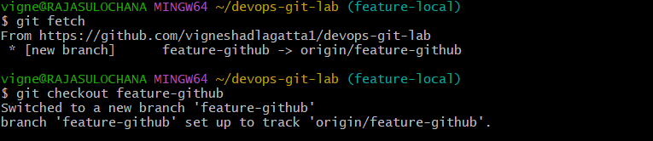

8) Merge Created Branch with Master in Local
git checkout main
git merge dev-branch

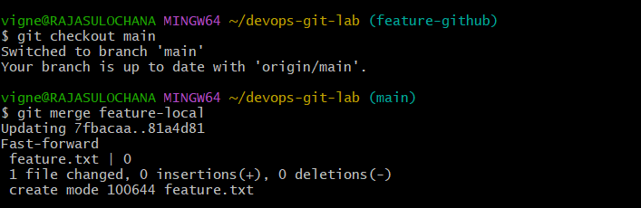

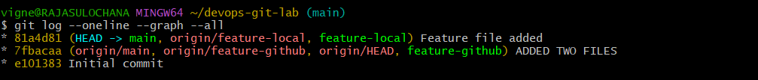

9) Merge Branch with Master Using Pull Request (GitHub)
Steps:
- Push branch to GitHub
- Click Compare & Pull Request
- Review → Merge → Confirm
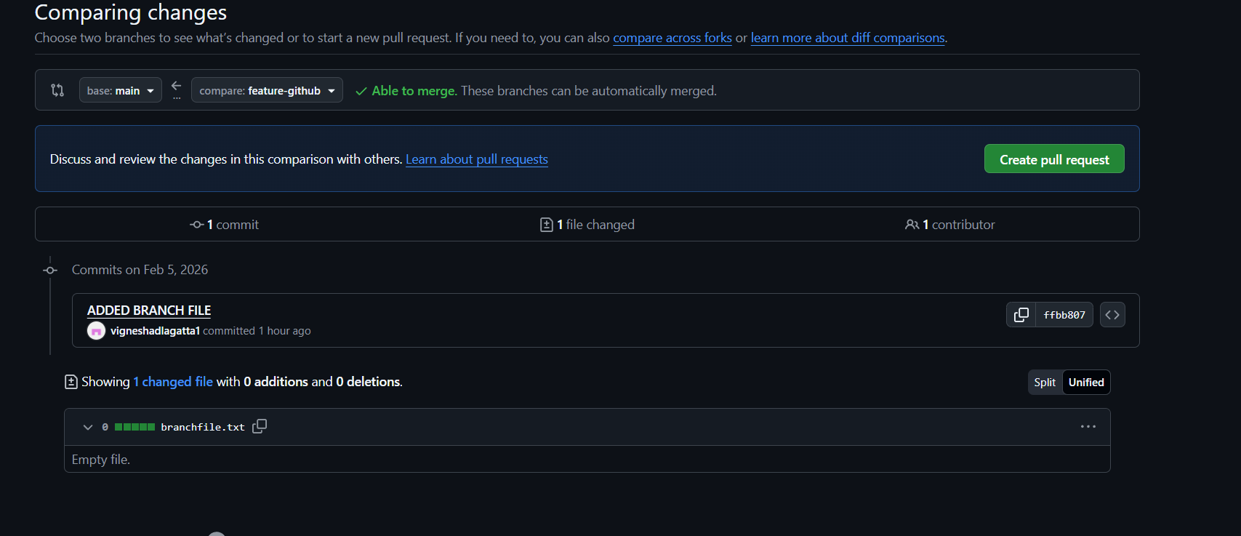

10) Create a File in Local and Send to GitHub Branch
git checkout dev-branch
touch newfile.txt
git add newfile.txt
git commit -m "New file"
git push origin dev-branch

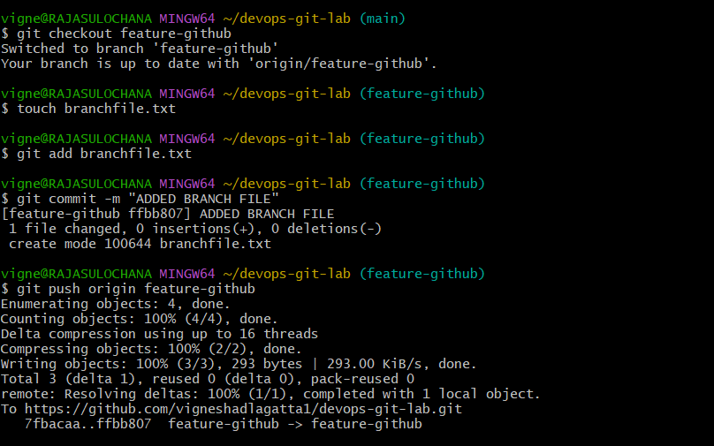

11) Clone Only a Specific Branch
git clone -b dev-branch https://github.com/username/repo.git

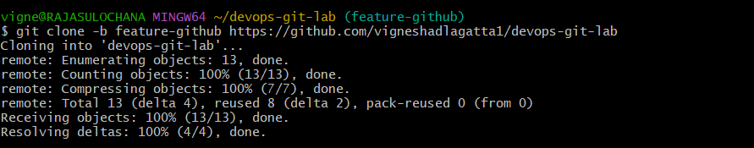

12) Create Password File and Make It Untrackable
echo "password=123" > secrets.txt
echo "secrets.txt" >> .gitignore

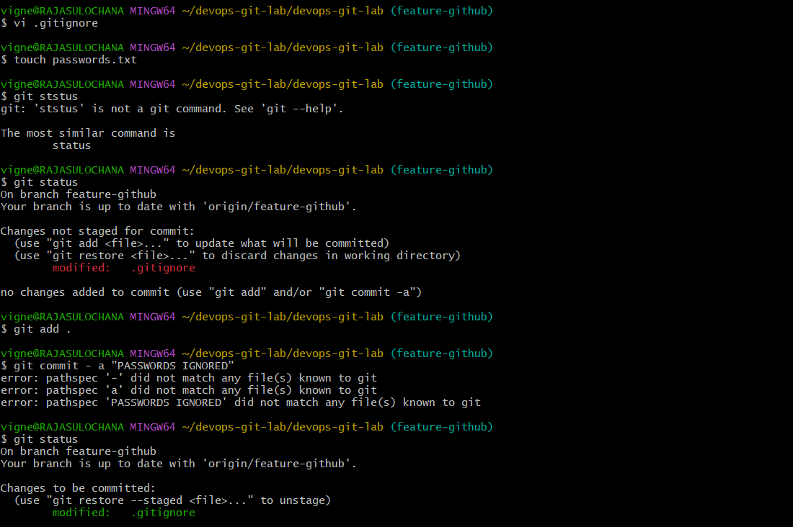

13) Commit and Reset Without Saving Changes
ls .git
git commit -m "Bad commit"
git reset --hard HEAD~1

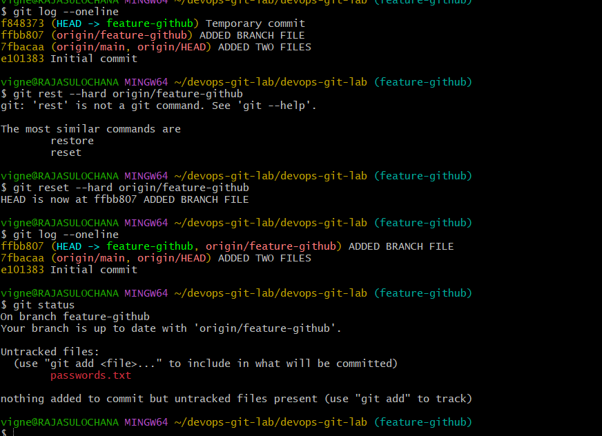

14 ) Revert a Committed Commit
git revert <commit-id>
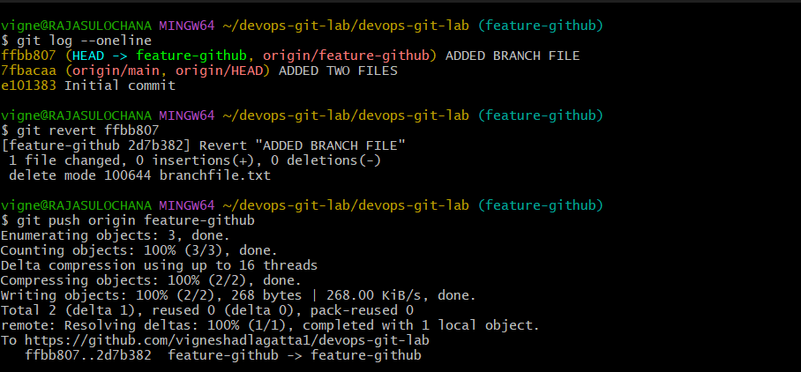

15) Stash a File Without Committing
git stash

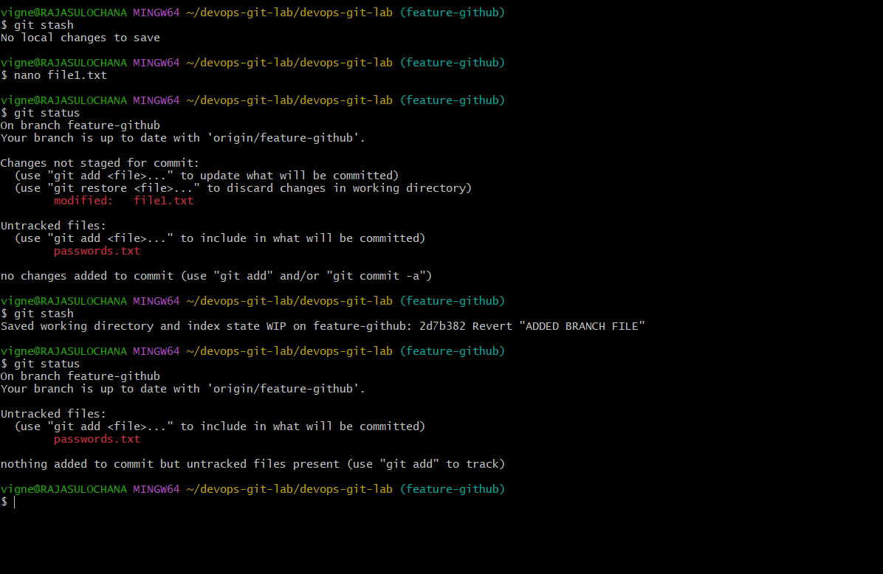

16) Undo Stash and Resume Work
git stash list
git stash pop

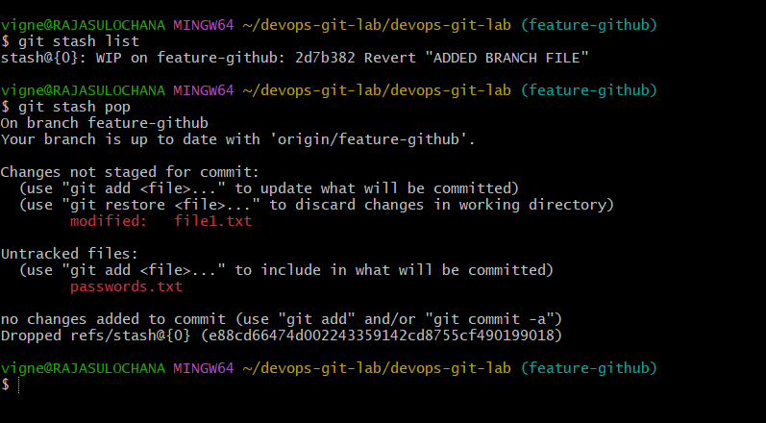

17 ) Generate SSH Key and Configure GitHub
ssh-keygen -t rsa -b 4096
cat ~/.ssh/id_rsa.pub
Add key in GitHub → Settings → SSH Keys.

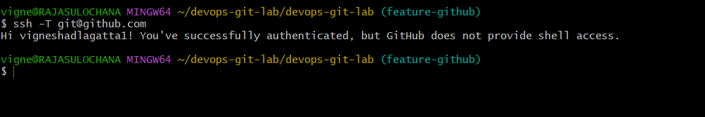

18) Configure Webhooks in GitHub
Purpose: Trigger CI/CD tools.
Steps:
- Repo Settings → Webhooks
- Add Payload URL
- Choose events
- Save
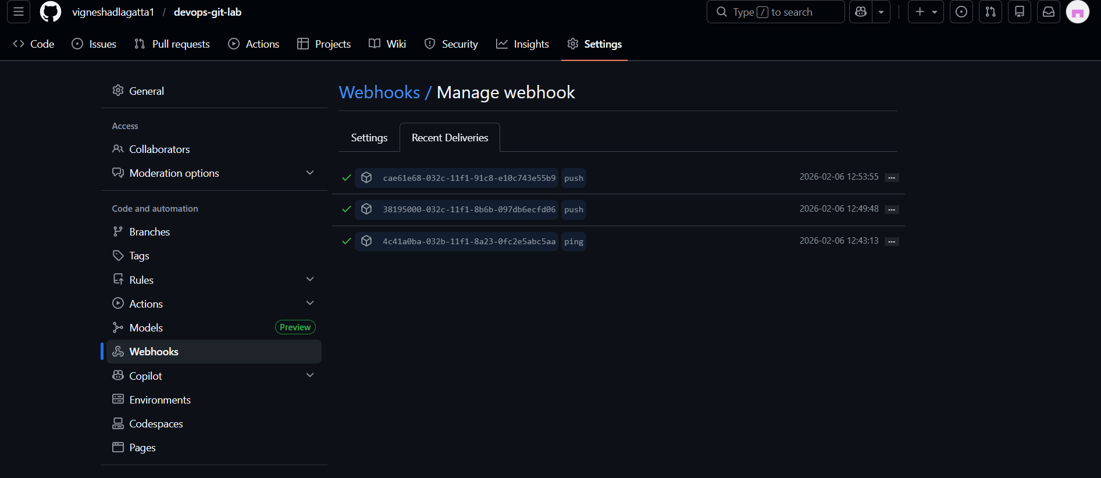
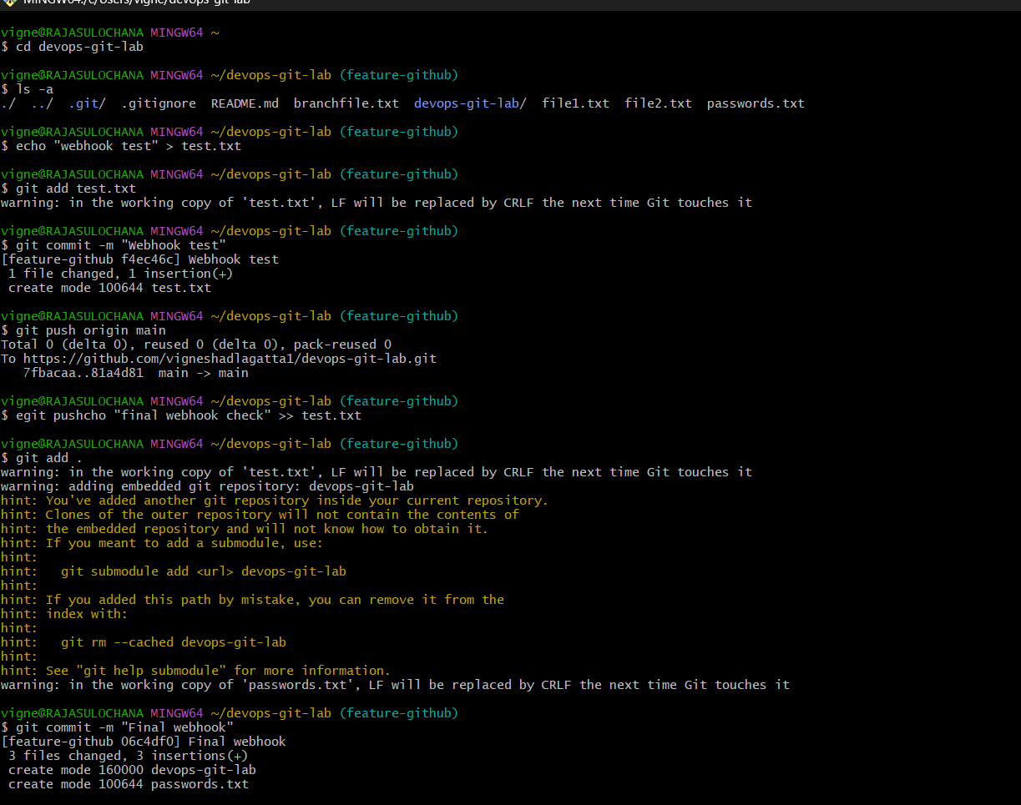
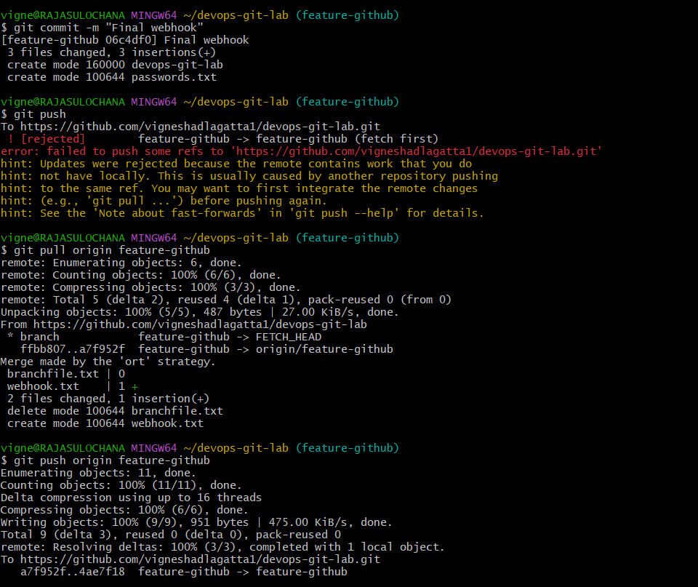
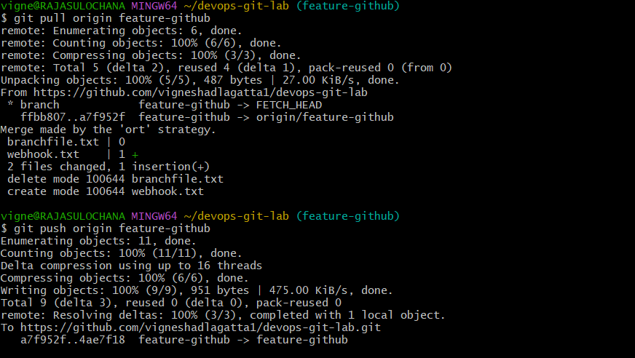

19 Basic Understanding of .git Directory

.git is the brain of Git. It stores everything.
Important files/folders:

.git/
├── HEAD → current branch
├── config → repo configuration
├── objects/ → commits, trees, blobs
├── refs/ → branches & tags
├── logs/ → commit history logs
├── index → staging area
Key point:
Deleting .git = project is no longer a git repo

20) Check all the logs of git.

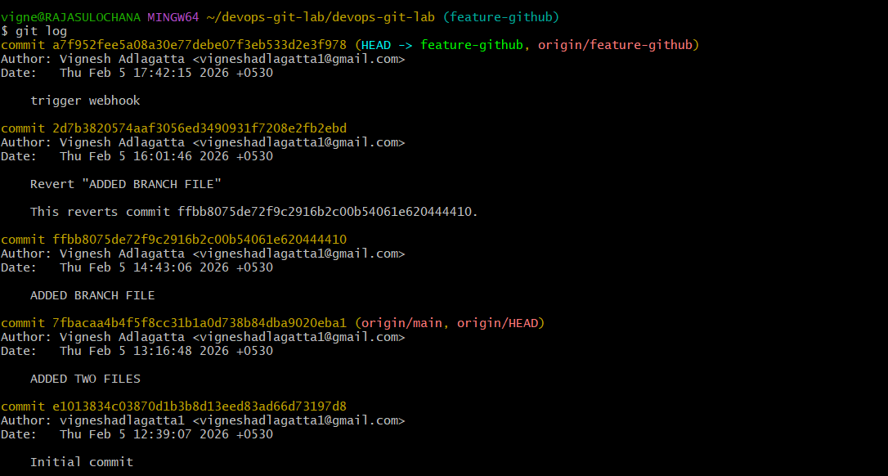

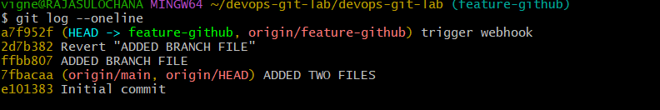

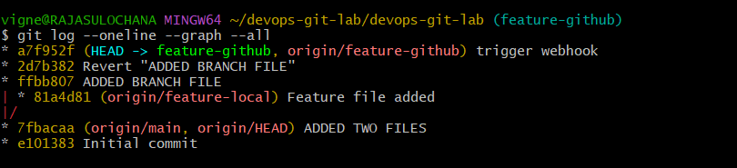

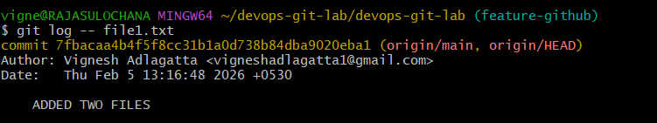

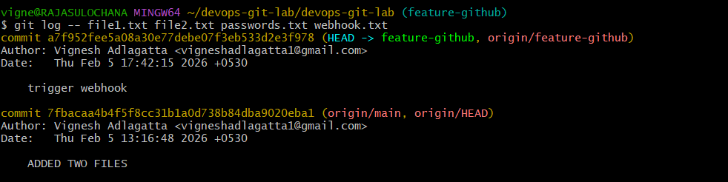
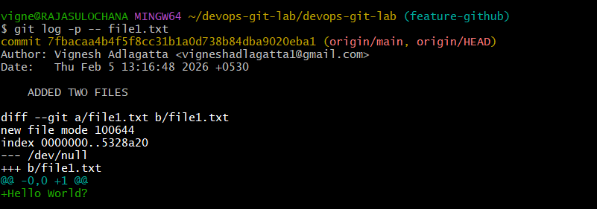

21 ) Rename the commit message.
git commit --amend -m "New message"

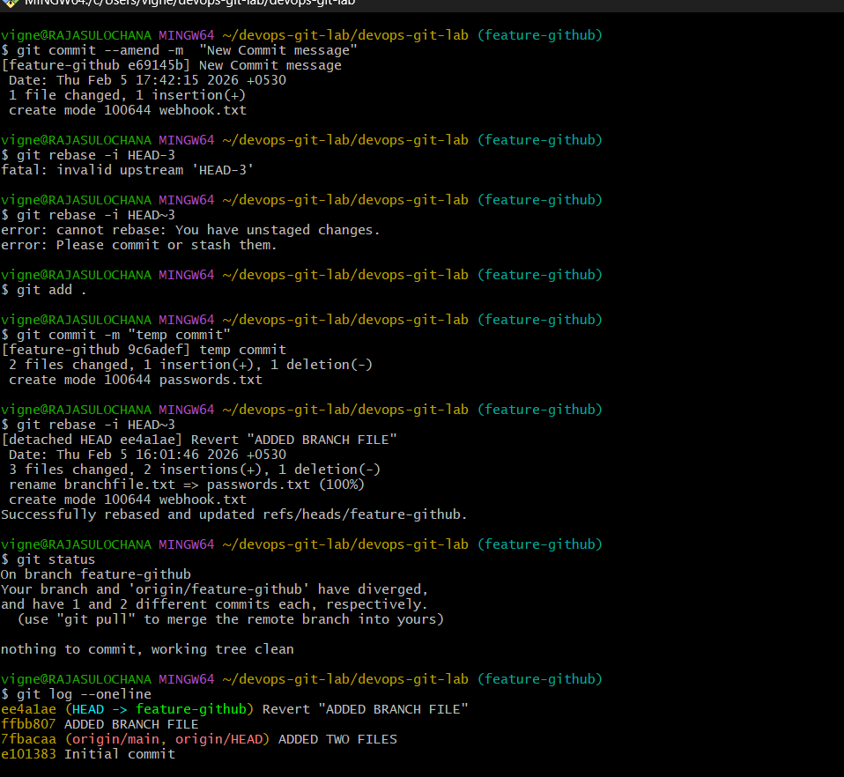

22) Merge multiple commits into one (squash)
Copy code
Bash
git rebase -i HEAD~3
# change pick → squash
